Lani and Todd

GREAT opening! Introduce names.

How did you do the person in powerpoint piece?

This is fantastic

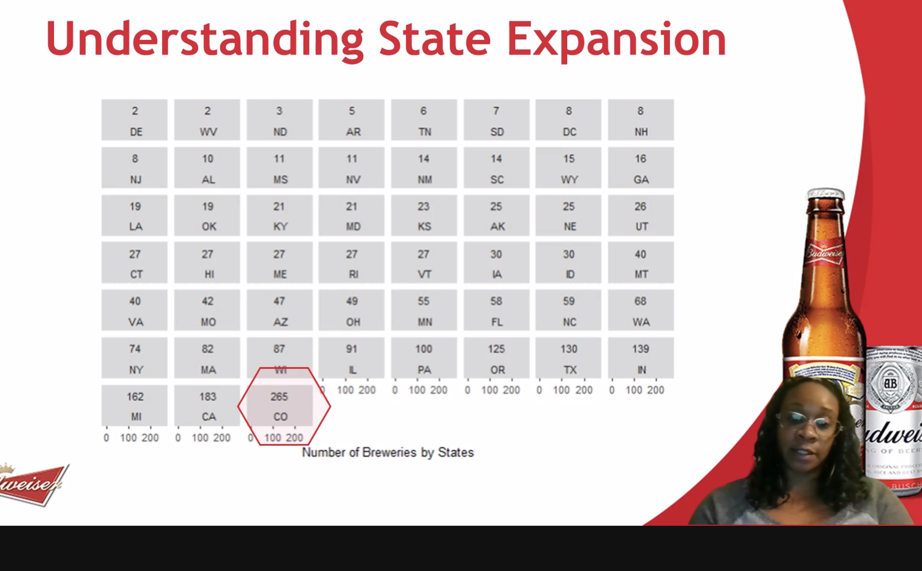

Good job..lots of info here… animated bullet points will help.

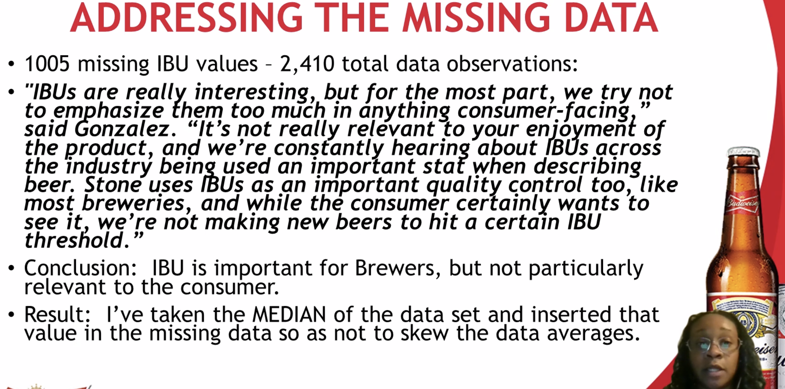

“Please forgive this…. “ alleviate this..

“Gold rush!” Yes! So many brewery reason.

Larger labels… 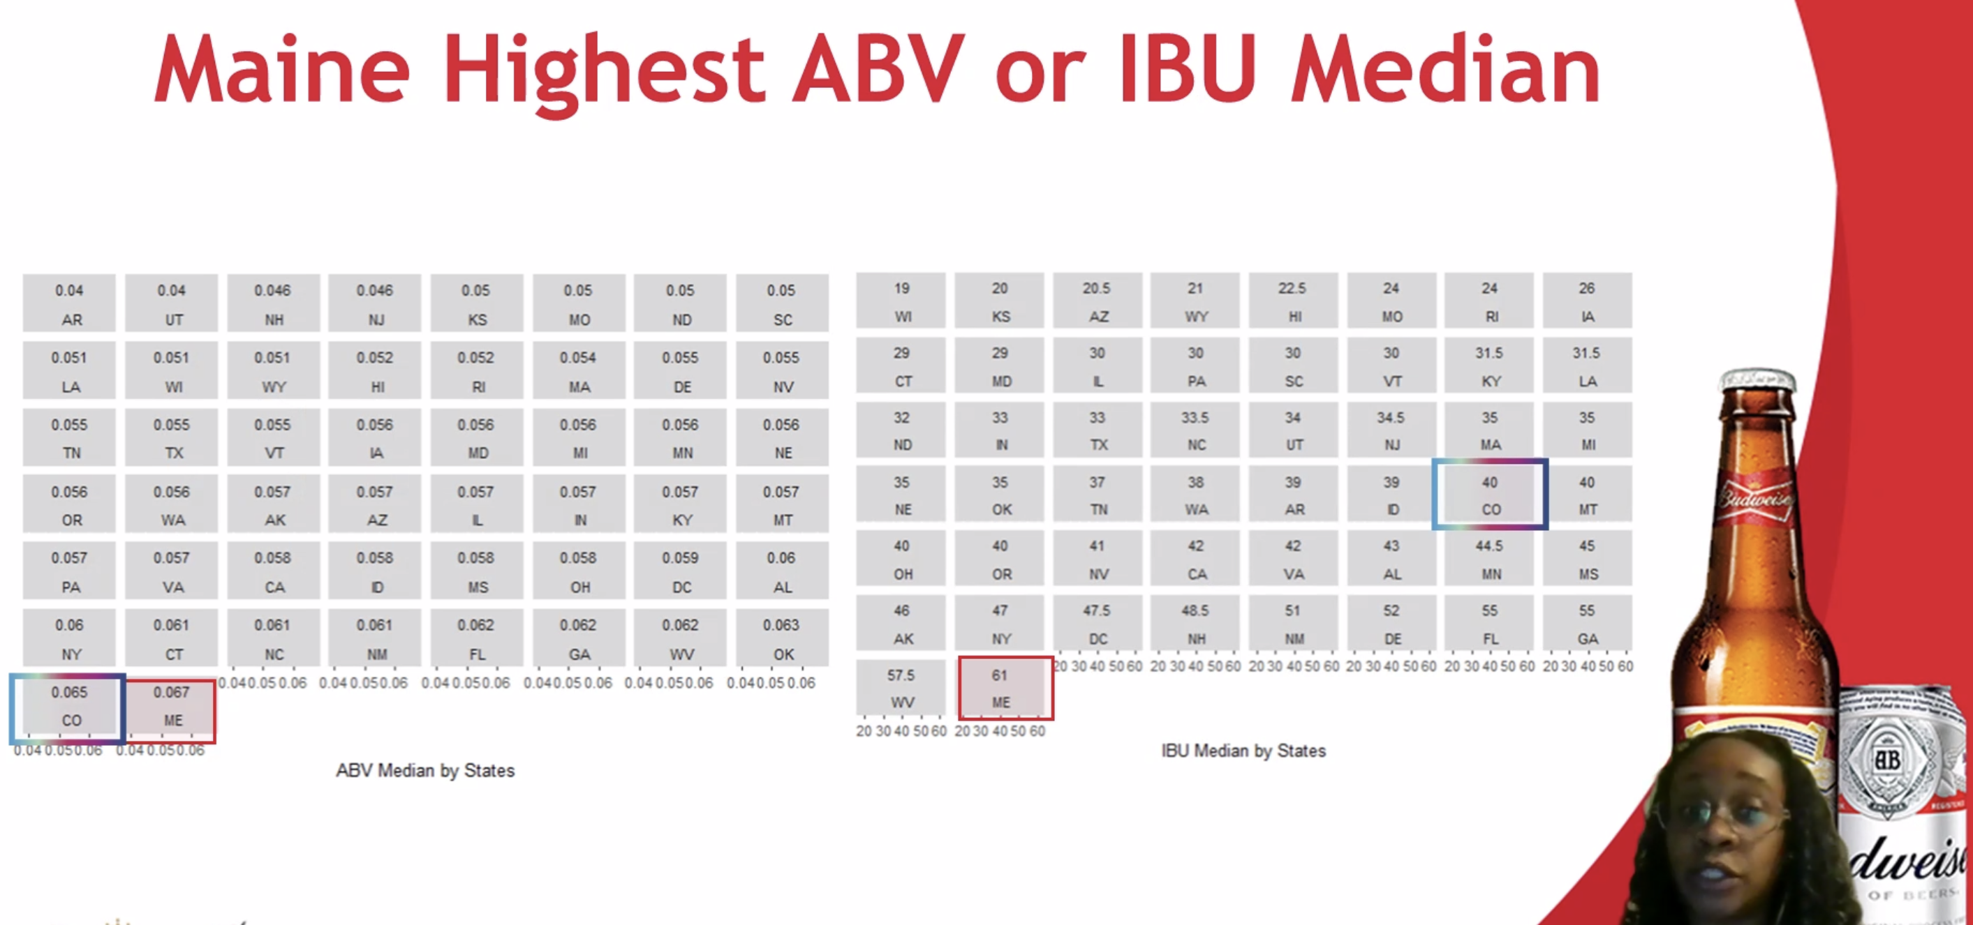

Maybe “on the left and …. On the right”

Standardize format on highest beers. (Comma)

Beuatiful plot … very readable.

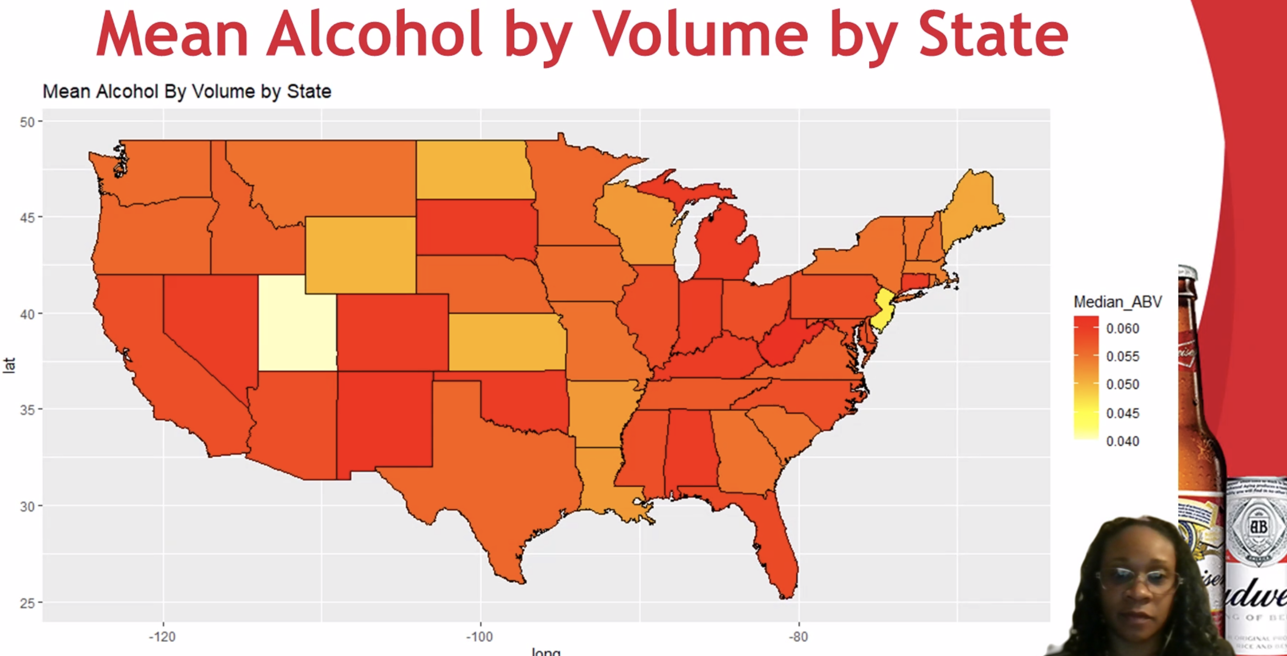

“mean” and “median” interchanged quite a bit.

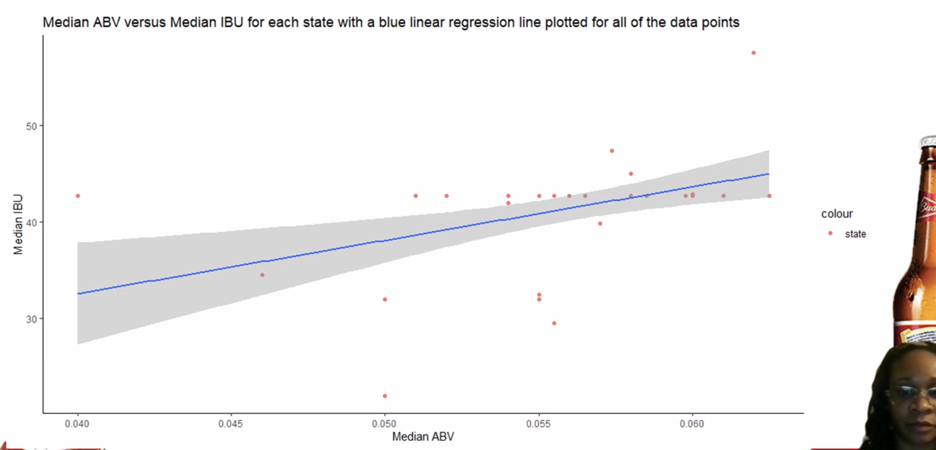

Why only a few data points? Ohhh…. Each state? Is this better than looking at all the beers?

Kill the legend.

Expanding into Colorado… great job with business suggestion.

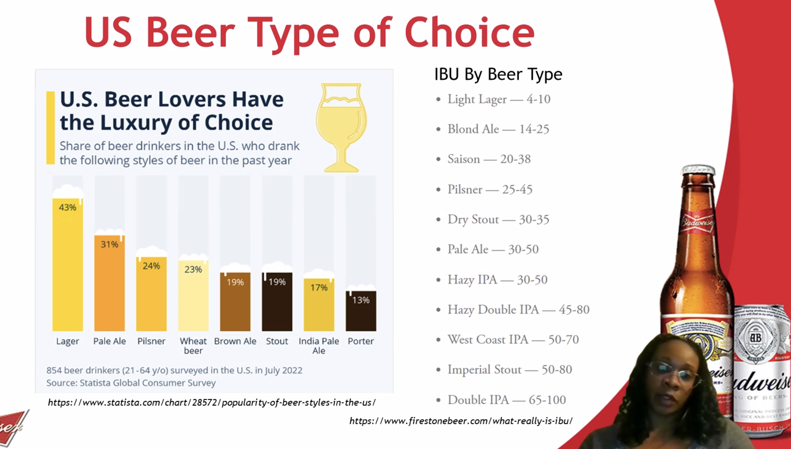

Polish exit with names and emails.